Crystal Skull Spiritual Journey for Healing trip to Puerto Rico and Bimini Island Bahamas.
December 19th/ 1stJanuary 2015- 2016
With Ancient crystal skulls Mahasamatman/Sammie, Jade, the Twins,
Kalif and Kathleen Murray
A Soul Call for Atlanteans and Lemurians to Unite, to Celebrate and Honour Life and to Illuminate the 13 Atlantean Temple Matrices with the consciousness of the 13 Ancient crystal skulls.
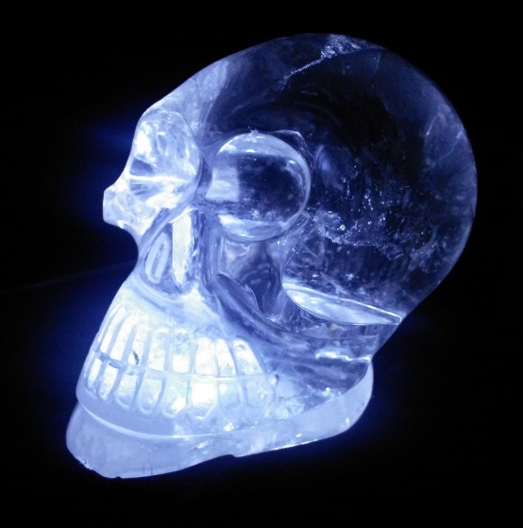
Mahasamatman or Sammie
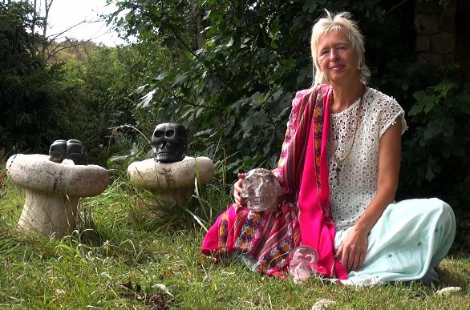
Kathleen Murray with Jade, the Twins, Kalif and Sammie
“I’m dreaming my dream and working my magic to awaken other dreamers and magicians to respond to the calls of Soul, Higher Self and Earth. To hear and respond to the calls of all Divine Beings in the Caribbean Sea, the Oceans and in the Taino Indians’ sacred land of the rainforests of Puerto Rico. We can find through cooperation and co-creation, the wonder and the joy which is Oneness.” Kathleen Murray
This is a Crystal Skull Healing Programme set in the Atlantean vibration of the Caribbean, where we can swim with wild dolphins, and share ceremonies in the sacred land of the Taino Indians in the rainforest of Puerto Rico.
We can sing the songs of our ancient of beings, which we know in our hearts. We can sing and sound and play music to wild dolphins and whales and all ocean creatures. We can co-create Peace with the Peacekeepers of the Oceans, the Earth and the Star Nations.
Crystal Skull Healing Programme with Mahasamatman/Sammie, Kalif, Jade and the Twins - ancient crystal skulls connecting with the ancient beings in the rainforests Puerto Rico and in the Caribbean Sea. The Council of Elders who come through the crystal skulls will assist us in our personal healing so we can transmit the qualities of Forgiveness, Love, Compassion, Trust, Freedom, Truth, Acceptance, Beauty, Grace and Surrender. We can become in unity a community which is focused on World Peace, Inner Peace and Galactic Peace.
It is time to put to Peace aspect of ourselves who are still holding ourselves responsible for destruction caused to Our Beloved Earth during Atlantean times. We all play out parts, then as now.
It is time to co-create a healing of the Golden Atlantean Matrix. It is a gathering of the peoples of Atlantis and the Priests and Priestesses of Atlantis. It is time to face the conflicts, to let go of the guilt, the shame; and in the process of forgiving Self and others, to make commitments to eternal Peace and Love. We all have opportunities for healing ourselves and through access to the purity of our hearts and the transformative power of our Love in Divine Service, we can humbly follow the guidance to create the magic and activate again the Golden Matrix of Atlantis.
We are the Guardians of the Golden Matrix of Atlantis, whether in our Star Nation self, or human form. We are the Upholders of the Temples and in our spiritual work we will begin the activation of the 13 Temple Matrices of Atlantis.
There will be opportunities to have personal sessions with the ancient skulls, either sitting in meditation by yourself, or having a personal guidance session from the Council of Elders, channelled by Kathleen Murray.
Cost for individual healing/meditation with Mahasamatman or Sammie, Jade, Kalif, or the Twins
Half an hour 50 US$ or £33, an hour 100 US$ or £66
Cost for a channelled guidance and healing session with the crystal skulls and the Council of Elders
Half an hour 110 US$ or £75, an hour 220US$ or £150

We will do group meditations/shamanic journeys and ceremonies with the Elements and Elementals of Nature, in the rain forest and on the beach. You are welcome to bring partners or family, children included who might not want to take part in the greater Healing Mandalas we will set up. Their presence is welcome and they can come without paying any contribution to the spiritual teachings. There will be plenty opportunities to do other activities, such as walking, hiking, zip lining and water sports/trips and beach activities. All are welcome to be together as a group to swim with the wild dolphins.

Contribution to the two weeks workshop/spiritual teachings is

I was excited to receive this invitation to spend time in a rainforest doing ceremonies and to explore an ancient land; also of course to swim with wild dolphins and spend time by the ocean and the beautiful Caribbean Sea.
Spiritual Teachings
The Council of Lemurian Elders that guide me have given me this information on our Personal, Global and Galactic Healing Mission. I was guided to look at information transmitted to me in 2011 by an ancient Jewelled Tibetan skull which, apparently was removed from Tibet by a German expedition and held in Nazi Germany while Hitler and his scientists were trying to access the power of Atlantean crystals again to control the Earth’s energies. It was placed in Russia at the end of World War Two. This skull is still in communication with me and will assist us in our Crystal Skull Healing Program; in healing ourselves and healing the sacred spaces or temples in the Earth.
Information from the Ancient Jewelled Tibetan Skull
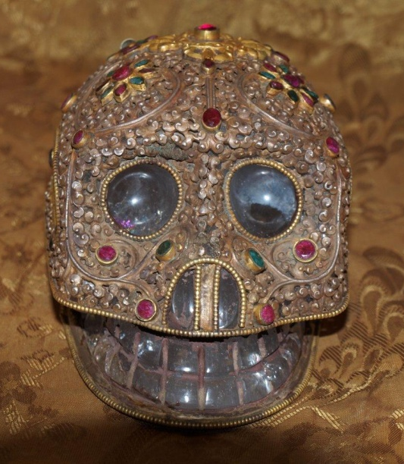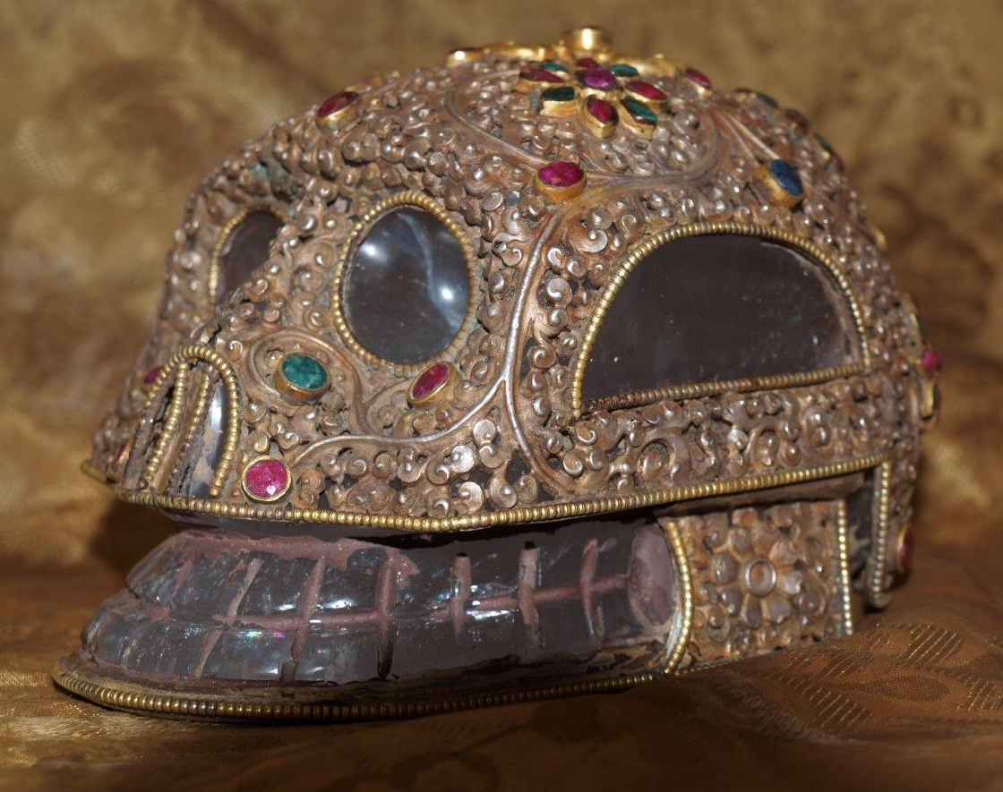
“Time to introduce people to the Timeline of Lemuria and Atlantis, to help people understand the significance of Lemurians and Atlanteans working together in Unity. One of the periods of the dark nights of Lemuria parallels the downfall of the first Atlantean civilisation. This was the beginning of star wars on Earth and the control of power of not only the temple circuit of 13 temples on the Earth’s surface but the temples in the inner Earth, to which there are portals in many different countries.
The myth about the 13 Crystal Skulls of Atlantis is well known. There were teams of 13 skulls, in addition to the 13 large quartz crystal skulls, working in all the energy networks or mandalas of the temples, and there were 13 levels of temples in the Earth. The temples are built in sacred geometrical form and fractal energy flows through the sacred geometrical structure. It is the Yin and Yang, the masculine and feminine of existence.
The network, or mandalas, of temples on and inside the Earth corresponds with the network or mandalas of temples outside the Earth in the other dimensions. These are the temples which exist in the star nations, the in between dimensional temples where the dragons and other mythical beings exist, the elestial temples and temples with the rays of the different crystal beings. All are connected as One.
The project now is transparency, to be able to let go of fears anddeep emotions, giving freedom to access the truth of being and truth of Self. True selves are discovered, or un-covered when there is surrender to personal and global transformation of the light and dark crystalline matrices in our cellular structure.
Transparency is a key, it is about transparency in all dimensions and the regaining of purity of heart, unity and community of Soul and Divine power in all dimensions.
At the end of the first Atlantean civilisation there was destruction to some of this vast temple network, towards the end of the second Atlantean civilisation the aim was more destruction of the temple network. To look at a larger picture after the first destruction; some of the temples became embedded with stellar frequencies that were starting to control the Earth’s energies. The rise of the next Atlantean civilisation did not mean that the temples which had been taken over were free again, it just meant that the energies that were present were used to control. After the destruction of the 3rd Atlantean civilisation the same thing happened, more of the temple network became controlled, infested by manipulating extra-terrestrial energies. The 3rd Atlantean destruction was the biggest and the most cataclysmic.
Atlanteans who knew in advance about the impending destruction escaped with their wisdom and knowledge to begin the seeding of other cultures around the world. And although sacred knowledge has been preserved in the Mystery Schools, the fall in the Earth’s energies through the fall in the temple network has never been recovered. The guardians and wisdom keepers of the Temples of Atlantis and Lemuria reincarnated in Egypt, the Mayan Lands, aboriginal peoples in many continents including Australia, North and South America, Tibet and Celtic lands.
There is a “disaster” timeline which is also seeded with the awakening of these memories; memories of destruction, disempowerment and the karma that each of us has potentially to fulfil. Anyone who entertains and believes the “disaster” idea is still very much controlled. “
This seeded conflict was experienced as heightening towards 2012 and it is still present in the collective subconscious and unconscious of humanity.Humanity has learnt to survive in energetically controlled environments, and non-holistic Atlantean technology has continued to be developed to control us and the Earth through projects like HARP, Chem trails, mind control, disease and un-natural and health damaging substances in our food and water and a wide spread use of pharmaceutical drugs as an answer.
It is time for any of us who can conceive of the opportunity for Unity consciousness, wholeness, the healing of dualities and polarities to regain our heart and soul aligned Divine power, putting to Peace aspects of ourselves and completing personal, global and galactic karma.
The difference now is that the beings who have controlled us are transforming, and we are transforming. In this movement of transformation we are united.They are transforming, we are transforming, the Earth is transforming.This is a movement into Unity consciousness, which can be seen paralleled by the wider spread acceptance and truth of the Quantum Universe. We are not meant to be completing our spiritual journey separately from other humans, or the Earth, Gaia. This is the time which has been anticipated, encoded, of coming into Wholeness.
From my understanding, the jewelled Tibetan skull was inside one of the inner temples, not one of the deep inner temples, one of the temples which had easy access, first of all to the Lemurians, who taught the Atlanteans teleporting between the inner dimensions in the temple network and the surface temples.
Thereincarnated Atlanteans began the foundation of Mystery Schools where wisdom and knowledge had to be kept secret in response to the loss of transparency. Crystal skulls were used to store the wisdom and knowledge, accessible by resonance; which is why we are guided now to open our hearts to this journey of healing.
Are you a Dreamer, a Magician, a Sage from Sirian Heritage perhaps? A Crystal Singer, a Crystal Dancer, a Healer or Guardian of the Temples of Atlantis or Lemuria; there is a vibrational call which sounds your name. Can you hear it?
Kathleen Murray is a spiritual teacher, artist, author and musician. She has been a guardian of crystal skulls since 1997 and is a channel for the Council of Lemurian Elders since 2004. In her team of crystal skulls who will come to Puerto Rico and the Caribbean is Mahasamatman or Sammie, an ancient ET skull who holds the records of Orion, Kalif a large contemporary carved smoky skull with elestial crystals growing inside, who gives information on Lemuria. Jade an ancient skull found in a temple in Mongolia (made of nephrite jade) with sigils carved on top of her skull and the Twins, a double jade skull with shamanic masks carved on the third eyes.
Kathleen will bring her musical instruments to play live music in meditations and shamanic journeys, including drums, Milltones, gong, Tibetan bells and bowls, chimes, song pods and Tibetan bell.
For more information on Kathleen’s work see www.crystals.eu.com and www.crystal-keys.com
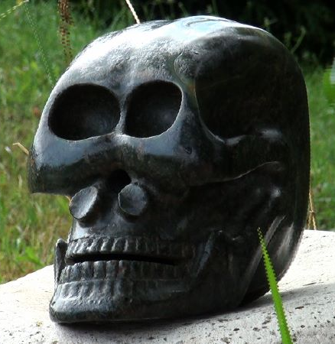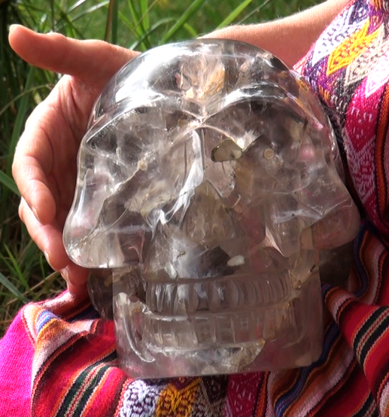
Jade Kalif
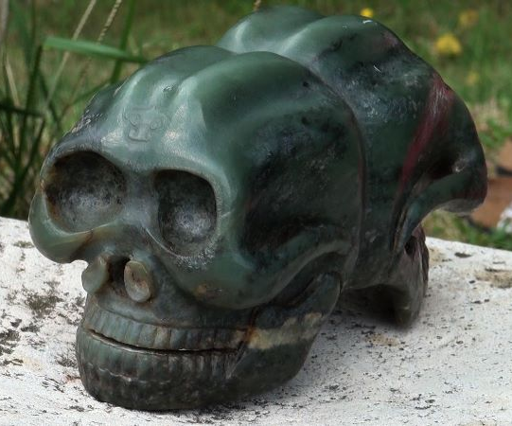
The Twins Kathleen Murray

